Project Identification

Project: | Breadmin
Prepared By: | Nooran El-Sherif, Sean Price, Dylan Roberts
Document Version: | 1.0
Published Date: | October 6, 2017

Contributors
The following individuals contributed to this document.
Name | Title
Nooran El-Sherif | Database and back-end developer
Sean Price | Team Lead
Dylan Roberts | Front and back-end developer

Distribution
This document is distributed to all the following people.
Name | Title
Anjana Shah | Professor
Jan Streekstra | Stakeholder / Lead Baker at Forno Cultura

Referenced Documents
This document refers to the following materials
Version number | Title | Author | Date | Source / Location
1.0 | Breadmin Project Vision | Nooran El-Sherif, Sean Price | 2017-10-06 | docs/BreadminProjectVision.doc

Revision History

Version Number | Revision Date | Summary of Changes | Modified by
0.2 | 2017-10-04 | Added information, added business context diagram | Nooran El-Sherif
0.3 | 2017-10-06 | Refined requirement scope statements, imported new Business Context Diagram | Dylan Roberts
0.4 | 2017-10-06 | Edited requirement scope statements (description of diagram) | Nooran El-Sherif
[Note: It is recommended that drafts be numbered 0.1 to 0.9, and that the first approved version be numbered 1.0. Thereafter, new version numbers will depend upon changes: 1.01, 1.1, etc for minor updates, 2.0, 3.0 etc for major changes.]

TABLE OF CONTENTS
1. Business Context Diagram 3
2. REquirements Scope Statements 4
3. High Level Business Requirements (HLR) Traceability 4
4. High Level Business Requirements Sign-Off 5

- Business Context Diagram 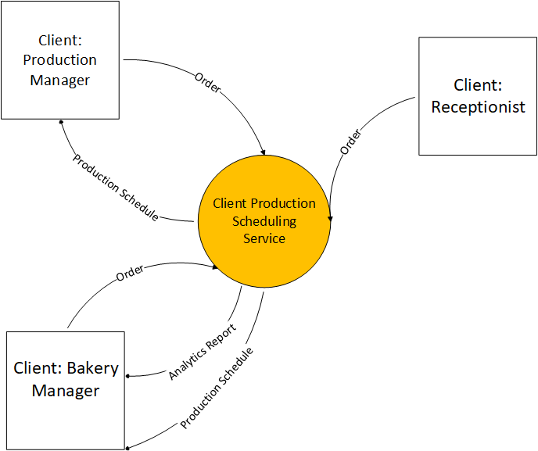
- Requirement Scope Statements
Requirement Scope Area | Description
Client Production Scheduling Service | Area responsible for providing order functionality, generating production schedules, and generating analytics reports

External Entity | Description
Receptionist | Client who will input customer orders
Bakery Manager | Client who will input orders, view production schedules, and view analytics reports
Production Manager | Client who will edit orders to mark them as complete and view production schedules

Information Flows | Description
Order:  Client: Receptionist  Client: Bakery Manager | Information entered for orders. Includes product type, product quantity, order total, customer information
Order:  Client: Production Manager | Order information that is edited and marked as completed
Production Schedule | Electronic document that display the production schedule in a weekly or daily view. Includes quantity of ingredients and step-by-step tasks
Analytic Report | Electronic document that displays analytics such as:  - Ingredient deficit generated by previous production  - Orders completed in selected time-period  - Products made in selected time-period
- Requirements Scope Statements
HLR# | Description | Priority  (H, M, L)
 | Client must be able to input customer product orders and customer information | H
 | Client must receive production schedule that will be generated from the orders schedule | H
 | Client must be prevented from inputting product orders once the schedule has reached capacity | H
 | Client must be able to submit like orders (orders with products that have been made in previous orders) for the day and they will be combined into a single quantity of product to produce that day | M
 | Client must be able to perform analytics - deficit of ingredients from the orders for the week, number of products made by day, number of orders completed by day | M
HLR06 | Client must be able to view and edit information and status of orders | M
HLR07 | Client must be able to collaborate with other members of ordering process through note section of application | L
HLR08 | Client must be able to use production schedules while offline | L

- High Level Business Requirements Sign-Off
The undersigned acknowledge their agreement with the contents of Version <x.x> of the High-Level Requirements document for <Project Name>.

Following approval of this document, requirements changes will be governed by the project’s change management process, including impact analysis and appropriate reviews and approvals, under the general control of the Project Plan and according to company policy. Approved Change Request Documents, if present, will be attached to this Requirements Document as updates.

Name | Project Role and  Functional Area | Date Signed
Jan Streekstra | Main stakeholder and Bakery Production Manager at Forno Cultura | 2017-10-06

* Note: physical signatures are not required. Email approvals are acceptable and should be appended to project documents.

